Warthogs

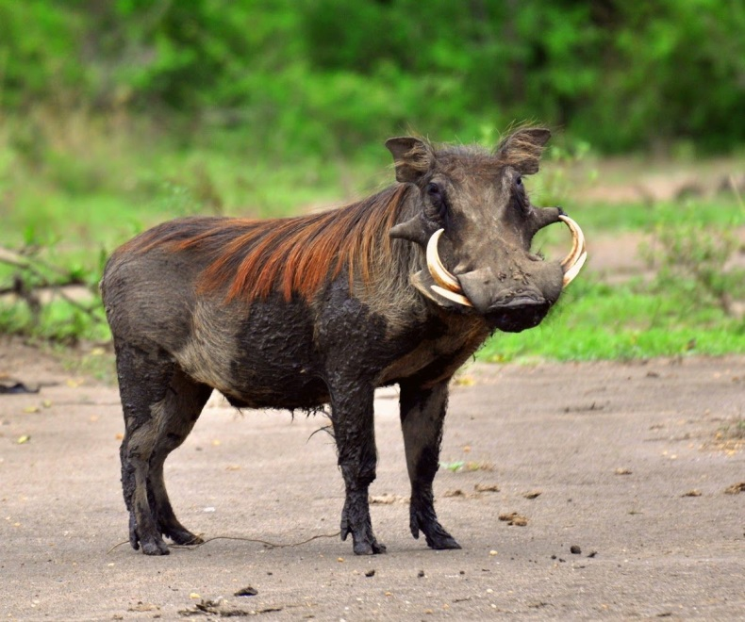 | Description:  Warthogs are members of the same family as domestic pigs, but present a much different appearance. Their large flat heads are covered with warts, which are actually protective bumps.  Warthogs have four sharp tusks and large nostrils at the end of their snout.  They have fur and their tails also end with a tuft of hair.
Home:  Warthogs live in Africa's southern Sudan and southwestern Ethiopia, in savanna woodland and grasslands. They are not picky about their homes. Instead of digging their own burrows, they find abandoned aardvark holes or natural burrows for homes. | Food:  Warthogs eat grasses and plants, and also use their snouts to dig or “root” for roots or bulbs.
Other interesting facts:

Did you know that a warthog’s tusks are actually their teeth?

Did you know that warthogs don’t have any warts?

Did you know that warthogs are actually really speedy?

