Year 2 – English
Home Learning Spring Term 1 Week 6 (8.2.21 – 12.1.21)
This week’s English work is based around the book, ‘Where the Wild Things Are’ by Maurice Sendak.  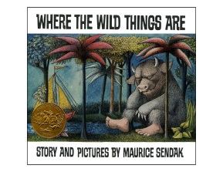  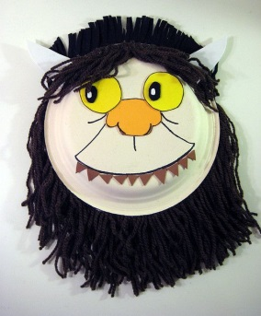 | Monday  Listen to the story on Tapestry. Look at pictures on Tapestry for inspiration.  What is the book about? What happens in the book? Can you retell the story verbally? (What happens at the beginning, middle, end?) Do you like the book? Why/why not?  Draw/make a ‘Wild Thing’ mask. Look on the internet for ideas. If you were a ‘wild thing’ what do you think you would look like?!!! (You could use a large cereal box?) | Tuesday  Watch Tapestry teaching video.  Write sentences describing your ‘Wild Thing’.  e.g.  He has large glowing yellow eyes.  His claws are sharp and long. ETC.
Wednesday  What is speech? How do we know when a character is talking in a story? How do we know which character it is that is talking?  Look through your books that you have at home and find examples of speech. This could be speech bubbles or speech marks. Look carefully to see how it is set out. | Thursday  Watch Tapestry teaching video.  Using the sheet, or drawing your own pictures, write speech bubbles for the different characters. What might the ‘Wild Things’ say? You could use ideas from the book or your own imaginative ideas.  e.g.  Oh, please don’t go. We will eat you up! We love you so!  You must now be KING of all wild things!  I think I will eat him up! | Friday  Watch Tapestry teaching video.  Look back at speech bubbles from Thursday. Can you now write this as speech, using speech marks?  e.g.  “I think I will eat him up!” snarled the Wild Thing.  “You must now be KING of all wild things!” said the Wild Thing.

