Year 2 – English Home Learning Spring Term 2 Week 2 (1.3.21 – 5.3.21)
This week’s English work is based around the book, ‘The Ugly Five’ by Julia Donaldson and Axel Scheffler.  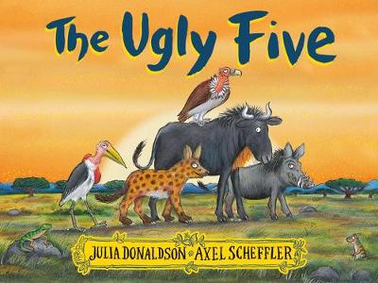 | Monday  Watch Tapestry video of story being read.  Watch Tapestry teaching video.  What is a rhyming couplet? Look at examples from the book.  Use worksheet as a support sheet. Match the words from the word bank to the rhyming words.  Can you add your own words to the list?  Can you write some sentences using the words? | Tuesday  Choose one of the ‘Ugly Five’ animals to research.  Lappet-Faced Vulture  Spotted Hyena  Wildebeast  Marabou Stork  Warthog  What can you find out about your chosen animal?  Jot down notes about your chosen animal.
Wednesday and Thursday  Watch Tapestry teaching video.  Write an Animal Fact File for your chosen animal. Use support sheet to guide you and look at my example of Warthogs.  If you would like to set your fact file out differently this is absolutely fine. My support sheet is just to give you a format and some ideas. I love originality! |  | Friday  Draw and colour/paint a picture of your chosen animal. Can you please try and make it the size of an A4 piece of paper.  Bring it to school next week in your bookbag, with your fact file sheet and I will make a display of them in the classroom!  Thank you.

