Year 2 – English
Home Learning Spring Term 1 Week 4 (25.1.21 – 29.1.21)
This week we will be learning about local animals and how to write riddles.  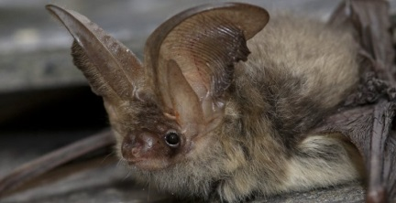  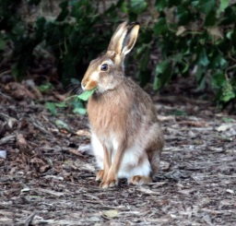 | Monday  Can you find out about some different animals that live in Norfolk?  You could use the Norfolk Wildlife Trust website to help you. https://www.norfolkwildlifetrust.org.uk/wildlife-in-norfolk/species-explorer/mammals  Choose one animal and try to find out 5/6 facts about it. Try to find out something unusual!  Record your facts in any way that you like. You could draw a picture of the animal in the middle of your piece of paper and write the facts around it, or just record the facts using a numbered list. | Tuesday  Watch powerpoint introducing riddles.  https://sway.office.com/Qv7lqrRkSYSk23jR?ref=Link  A riddle is a type of poetry that describes something without actually naming what it is, leaving the reader to guess.  Read the riddles and work out what is being described.
Wednesday  Watch video on Tapestry  Look back at your chosen animal from Monday. Write a riddle about your chosen animal, thinking carefully about how to order your sentences so that the least obvious clues are first and the most obvious last.  Can you think of different ways to begin your sentences, not all starting with ‘I’? e.g Sometimes I … , If you look carefully … , Beware I can … | Thursday  Watch video on Tapestry  Look back at your riddle from yesterday. Can you improve it in any way? Are your clues in a good order?  Write up your riddle on a folded piece of paper, so that the writing is on the front and the picture of the animal is inside (see video on tapestry for modelled lesson). | Friday  Spelling Challenge!  How many different words can you make out of these letters? Each letter can be used more than once.  a i n l m t p d g o  Extension: Can you now write some sentences using the words?

