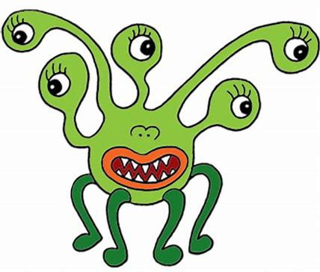

Bert Bash Dorris Missy

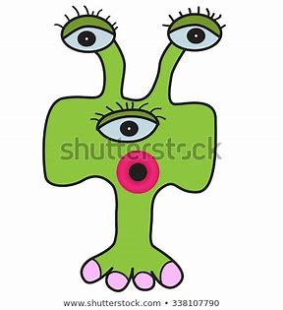
Bop Tracey

Draw out the monster’s legs to show the correct number of legs altogether for each sum. Write the multiplication sum too with the answer.
I have 3 Bert monsters. How many legs altogether?
I have 5 Dorris monsters. How many legs altogether?
I have 2 Missy’s monsters. How many legs altogether?
There are 10 Bops monsters. How many legs altogether?
There are 9 Tracey monsters. How many legs altogether?
There are 5 Bash monsters. How many legs altogether?
I have 6 Bert monsters. How many legs altogether?
I have 4 Bops monsters. How many legs altogether?

